CHAPTER 10: Transferring and transforming energy
Worksheet 10.3

A costly escape
Student: Class:

Investigating insulators
● Form six groups and use one can per group.
● Surround each can except one with a different material.
● Measure out and pour 100 mL of hot water into each of the cans.
● Measure the temperature of the water in each can. Repeat the measurement of temperature every 5 minutes for 20 minutes.
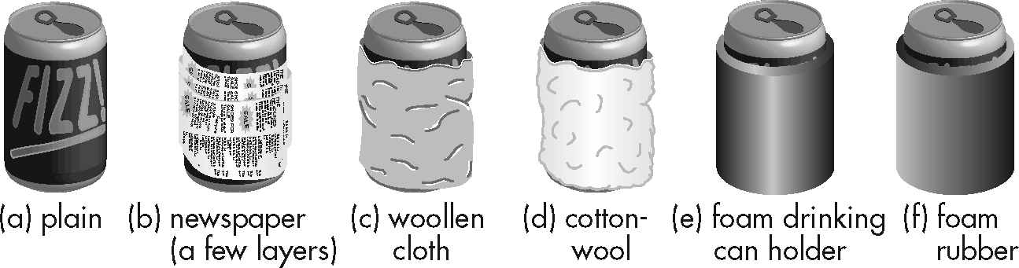

You will need:
6 empty soft drink cans
6 thermometers
newspaper
woollen cloth
cottonwool
foam drink can holder
foam rubber
hot water
measuring cylinder
sticky tape
Temperature of water in cans (°C)
Can covering | Time (minutes)
 | 0 | 5 | 10 | 15 | 20
None
Newspaper
Woollen cloth
Cottonwool
Foam can holder
Foam rubber

1. Draw a bar graph that will allow you to compare the drop in temperature of the water in the cans after 20 minutes.
2. Which covering appears to be the most effective insulator?

3. Which one or more of the three methods of heat transfer does the most effective insulator reduce?

4. Use your data to suggest a good container for a mug of hot chocolate.

5. Why was one can left without a covering?

6. Are your conclusions reliable? Discuss the difficulties encountered in making sure that the comparison of insulators was fair.

